CTM-I Use Case

Back-Door Futures Delete

Version 0.2

Use Case Name | Back-Door Futures Delete
Actor | App Support
Pre-conditions /Assumptions | User has Browser and is aware of the http path to the application.  User has successfully logged into the CTM-I application.  User has the right role to see the menu options.
Post Conditions | None
Screenshot | 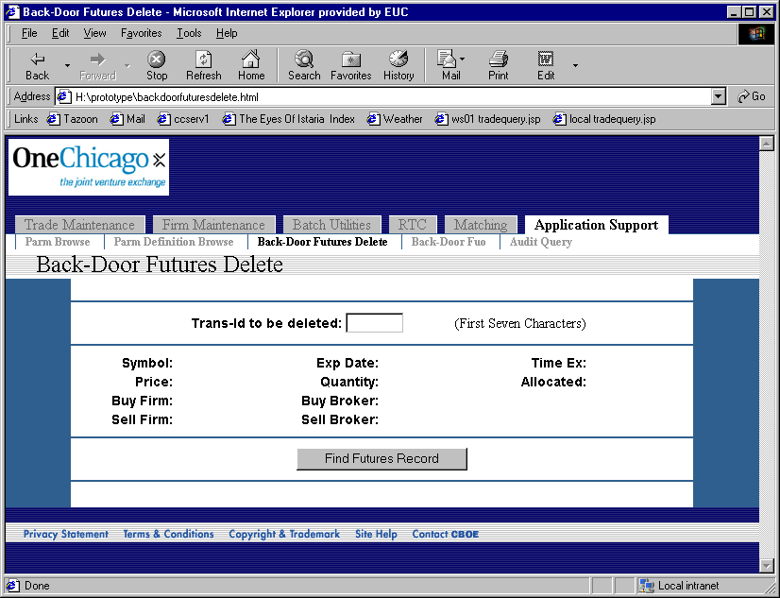
Flow of Events | - User selects “Back-Door Futures Delete” from the menu.  - Back-Door Futures Delete screen displays  - User enters a Transaction Id.  - User presses the button to find the futures record.  - Request is sent to CTM-R to find the futures record by transaction id  - The futures record returned from CTM-R is displayed on the screen  - The following fields are displayed  - Symbol  - Price  - Buy Firm  - Sell Firm  - Expiration Date  - Quantity  - Buy Broker  - Sell Broker  - Time of Execution  - Buy Side Allocated (Yes / No)  - Sell Side Allocated (Yes / No)  - The user presses the button to delete the futures record.  - Request to delete the futures record is sent to CTM-R.  - Any feedback from CTM-R is displayed on the screen.
Alternative Path | 4.1 Transaction ID is checked to be numeric; if not the original screen is redisplayed.  5.1 Any errors, including record not found, from CTM-R are displayed on the screen.

